Dear Careers Lead

The Belfast Health & Social Care Trust continues to be one of the largest providers of work experience to young people in schools and colleges across Northern Ireland. We are committed to raising the aspirations of young people through the experiences it provides via placements, open days and support for a range of career’s events and activities.

After the success of the first Student Debate in 2015, the Belfast Trust in partnership with Work Inspiration: Business in the Community will be hosting the 5th Student Healthcare Debate in Autumn 2019. We hope that involvement in the debate will support students further in their consideration of a healthcare related career and in their UCAS applications. Debate topics will be public health focused and current issues facing healthcare professions.

We are inviting expressions of interest from school students who have participated in or will participate in a healthcare related work placement to submit a debate team on behalf of their school. Teams are invited to complete the attached application form, which should be submitted electronically to reach the shortlisting panel by Friday 11th October 2019.

Four teams will be shortlisted from applications to participate in the semi-final debates, which will take place on Monday 11th November 2019 at 2pm in the Education Centre, Royal Victoria Hospital. The two semi-finalists will then be invited to compete in the final debate event, which will be held the first week of December 2019 (date to be confirmed), in the Education Suite, Mater Hospital. All debate participants will receive recognition of their contribution to the process and the winning team will be presented with a prestigious winner’s award trophy for their school.

We look forward to receiving your school’s application and are happy to answer any queries you may have.

Kind regards

BHSCT Work Experience Co-ordinators

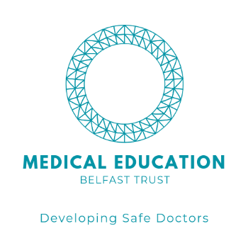

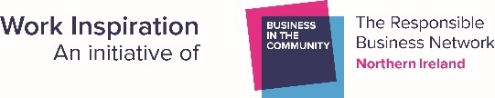
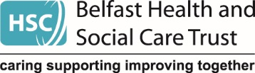
To enter each member of the debate team must be in Year 13 or 14 and will participate or have participated in a healthcare work experience placement.

Only one team application per school will be accepted.

School team should consist of a maximum of 5 students, all of whom have a healthcare career choice focus.
Each team should answer BOTH questions in no more than 1000 words per question.
Applications deadline Friday 11th October 2019.
Return completed applications to Kerri.McArdle@belfasttrust.hscni.net

- Smokers should pay for their health care. Discuss

- The Government should impose higher taxes on all unhealthy foods. Discuss.

Return your application to Kerri.McArdle@belfasttrust.hscni.net by Friday 11th October 2019

