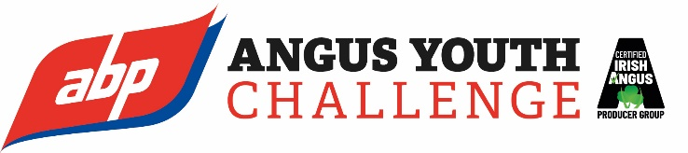

Dear Teacher,

Due to the passing of Her Majesty the Queen Elizabeth II and in respect of the period of national mourning which we now understand includes school closures, the closing date for entry to the ABP Angus Youth Challenge has been extended until 3rd October 2022 at 12pm, noon. The exhibition for judging of shortlisted entrants will still take place on 28th October in the Logan Hall Balmoral.
Should you have any queries with regard to your entry or if you wish to discuss the process further please do not hesitate to make contact with the ABP Angus Youth Challenge schools co-ordinator, William Delaney by emailing schools@certifiedirishangus.ie
More information is available at: www.abpangusyouthchallenge.com

Yours sincerely
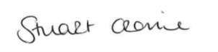
Stuart Cromie
ABP

